Process Improvement: Data and Data Analysis Drives Results
__________________________________________________
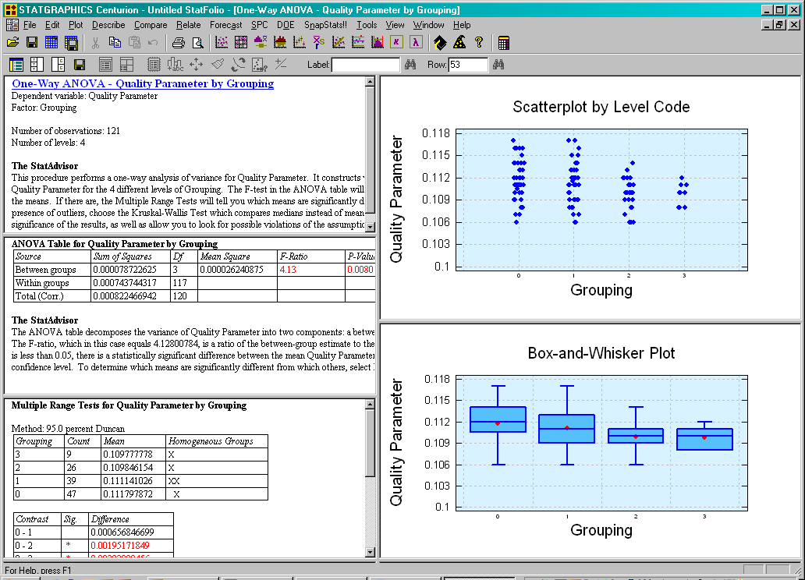

A product quality issue arose with an important customer of a major specialty chemical company. This was a challenging problem since the customer was running their own proprietary product performance tests and providing information back to the supplier regarding acceptable or unacceptable results.

The supplier had to therefore take measured results provided by the customer and relate this back to the entire manufacturing process and supply chain to not only pursue root cause analysis that lead to the problem but to also investigate relationships and take specific actions to drive process improvement.
The step improvements to move product quality to a desirable value along with a reduction in overall batch to batch variation was achieved.

An extensive data set was assembled including quality characteristics of raw materials coming into the supplier’s site, process data and in-process sample analysis of the chemical manufacturing units producing intermediate chemical components. This was linked with data from the blending process taking these intermediate components which incorporated them into finished batches of material sent to the customer.

Statistical analysis included SPC control charting to assure stability of quality and process characteristics. Correlation and multi-variable analysis was used to look for relationships between variables. Analysis of variance (ANOVA) was used to determine statistically detectable differences in averages and differences in variability. Design of experiments (DOE) was used to pursue specific hypotheses identified from the other analyses to look at and characterize relationships between variables and their effects on end product quality.

Actions were taken based upon the results of these statistical analyses that lead to not only resolving the product quality issue but also in a further reduction in both process and batch to batch product quality variation. Authored by: Robert Wojewodka


From: STATPOINT TECHNOLOGIES, INC.
560 Broadview Avenue 540-428-0084 phone
Suite 201 540-428-0089 fax
Warrenton, VA 20186 info@statgraphics.com

